**PF LAB :9**

**24K-0514**

**MUHAMMAD UMER FAROOQ**

# QUESTION 1:

Write a C function that takes two numbers as input and returns their product.

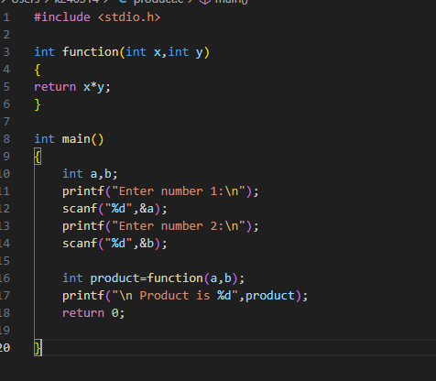

OUTPUT:

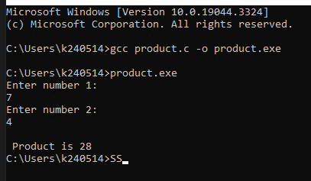

## QUESTION 2:

Write a function that checks if a given number is even or odd.

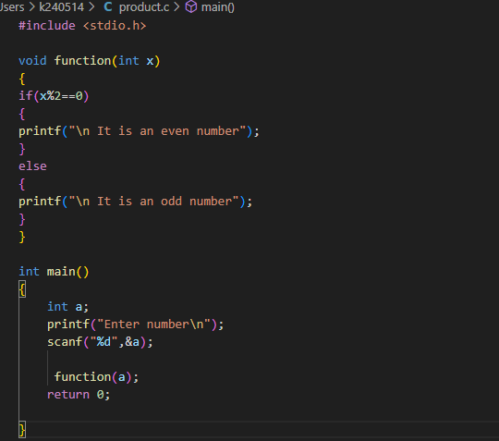

OUTPUT:

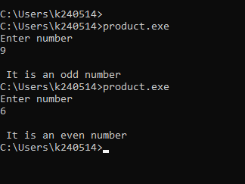

### QUESTION 3:

Write a program that takes a destination string and a source string as input. Then, take an integer n as input and append only the first n characters of the source string to the destination. Print the new concatenated string.

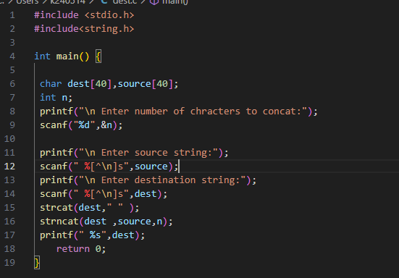

OUTPUT:

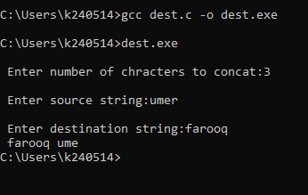

#### QUESTION 4:

Write a program that initializes a 2D character array with a list of words. Then, take a word as input from the user and check if it exists in the array. Display "Found" if it’s there, otherwise display "Not Found".

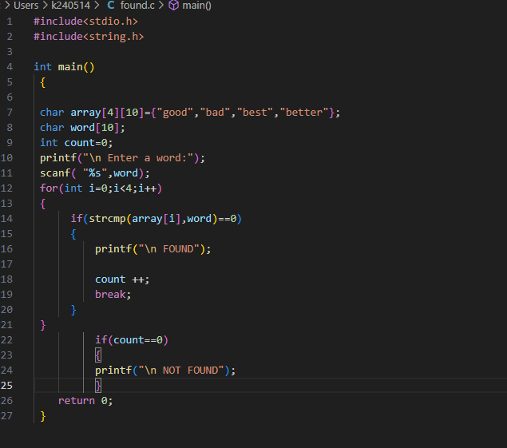

OUPUT:

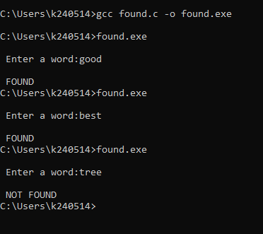

##### QUESTION 5:

Create a program that accepts a 2D array of strings (e.g., 5 words with a max length of 20 characters each). Determines if each word (row) is a palindrome. Outputs “Palindrome” or “Not Palindrome” for each word. A palindrome is a word that reads the same forward and backward. For example: "madam", "racecar", "level", "radar".

##### 

OUTPUT:

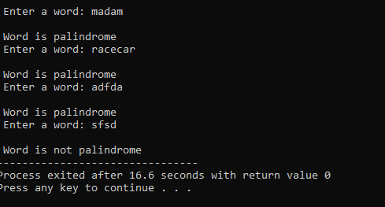

###### QUESTION 6:

Create a C program that swaps the values of two integers using a user-defined function, Swap Integers. The user inputs two integer values, and the program uses the function to swap them. It should perform the swap and display the updated values.

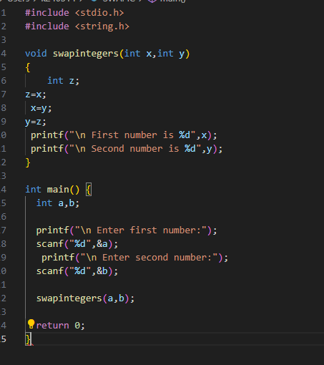

OUTPUT:

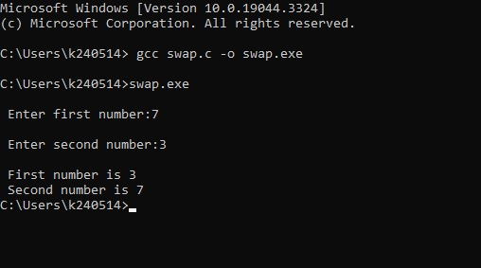

QUESTION 7:

Implement a function that checks if a given integer is a prime number. Use this function in the main program to check if numbers entered by the user are prime.

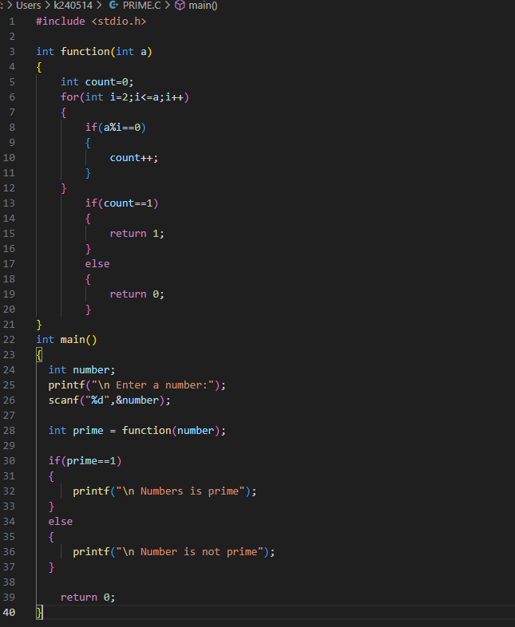

OUTPUT:

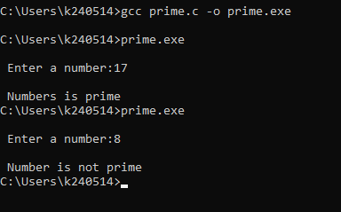

QUESTION 8:

Write a C program with a user-defined function calculate to perform basic arithmetic operations such as addition, subtraction, multiplication, and division. The program should take two numbers and an operation choice as input, and then use the function to perform the operation.

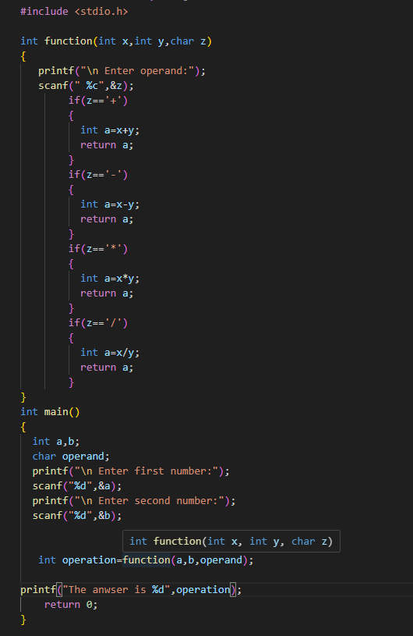

OUTPUT:

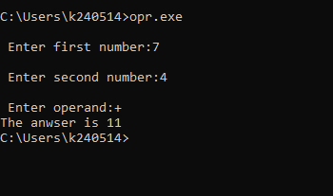

QUESTION 9:

Create a function that reverses a given string and returns the reversed string. Use this function in the main program to display the reversed string entered by the user.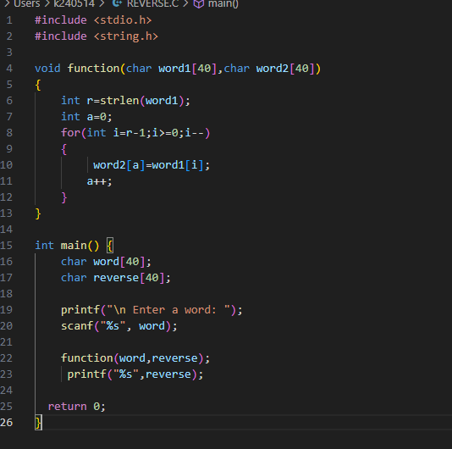

OUTPUT:

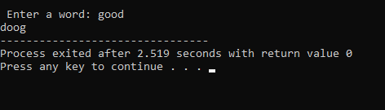

QUESTION 10:

Create a function that returns the maximum and minimum element in an integer array. Use this function in the main program to find the maximum and minimum from an array entered by then user.

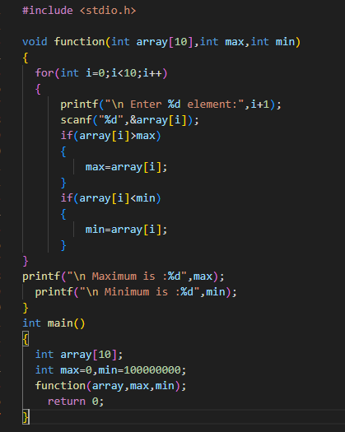

OUTPUT:

